

**KULLIYYAHOFENGINEERING**

**END-OF-SEMESTER EXAMINATION**

**SEMESTER 1, 2020/2021 SESSION**

|  |  |  |  |  |  |
| --- | --- | --- | --- | --- | --- |
| Programme | : | **Mechatronics Engineering** | Level of Study | : | **UG 4** |
| Time | : | **9.00 am – 9.00 am (16 Jan 2021)** | Date | : | **15 January 2021** |
| Duration | : | **24 hours** | **Name: Mosab Alsamman** |  | **Matric:1525327.** |
| Course Code | : | **MCT 4334 / MCTE 4342** | Section(s) | : | **1** |
| Course Title | : | **Embedded System Design** |  |  |  |

This Question Paper Consists of **Three (3)** Printed Pages (Including Cover Page) with **Two (2)** Questions.

**INSTRUCTION(S) TO CANDIDATES**

* Total mark of this examination is **40 marks.**
* This examination is worth **40 %** of the total course assessment. ● This is an open book, open notes examination. Answer **ALL QUESTIONS** ● Marks assigned to each question are listed in the margin.
* **Note that one of the conditions to pass the course is to obtain at least 50 % of this examination.**

|  |
| --- |
| **DECLARATION**  By answering this final examination, I hereby declare that:   * The whole answer of this final examination is my own work. * I do not receive any help from any other parties in answering on any part of this final examination. * I do not give any clue, hint or work to other students in answering on any part of this final examination. * I understand that any form of cheating or attempt to cheat is a serious offence which may lead to dismissal. |

**QUESTION 1 (10 marks)**

Smart electronic products are becoming fundamental to the way people live, and embedded systems now permeate everyday life. Microprocessors and microcontrollers can be found in practically every electrically powered product that we use. This ubiquity is helping to shape some of the key trends in embedded systems development, driving both functionality and ease of use.

Here are the top 5 emerging technologies in an embedded system application:

1. Smart Farming
2. Intelligent Transport Systems
3. Edge AI
4. Wearable Devices
5. Building Automation

Choose any 2 emerging technologies and briefly discuss the pushing factors of the trends and the issues behind it with examples in order to illustrate your answer.

**(5)** a)

**(5)** b)

**QUESTION 2 (30 marks)**

The video games are a very powerful force for getting the youths interested in technology. It has way bigger knock-on effects than people may realize.

At age 12, having mastered BASIC, Musk sold the code for his PC game [Blastar](https://www.theverge.com/2015/6/9/8752333/elon-musk-blastar-pc-game) to a PC magazine for approximately $500 (Figure 1). Eleven years later, he and his brother founded Zip2, a company that provided city guides, maps, and yellow pages for the newspaper industry, and which they eventually sold to Compaq for $307 million. Musk says he did most of the coding for Zip2, mostly at night when the software wasn't in use.

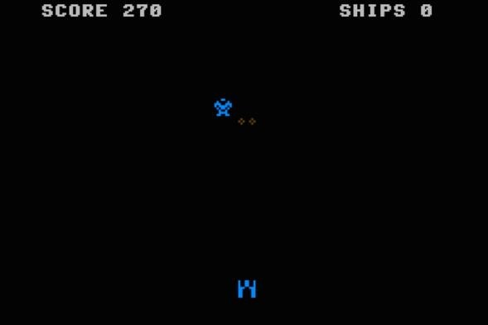

**Figure 1: Elon Musk and his Blaster Game.**

“Part of the reason, maybe the reason, I probably wouldn’t have started programming if it wasn’t for video games or wouldn’t have been as interested in computers and tech if it wasn’t for video games.”Musk said.

Meanwhile, Breakout Game was one of the most popular games in the long history of the Atari 2600. Head Engineer Al Alcorn, assigned Atari employee Steve Jobs, a lowlevel technician working a night-shift to design the single-player game, which was similar to Pong (Figure 2). At a time when microchips were extremely expensive, Atari

**2**

were anxious to reduce the cost of each Breakout coin-op, and offered Jobs a $100 bonus for every chip he managed to eliminate from the initial concept. Jobs in turn asked his friend Steve Wozniak to do it together.

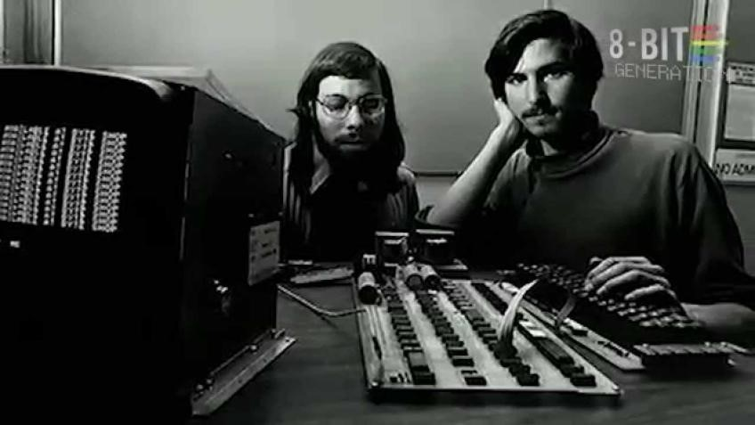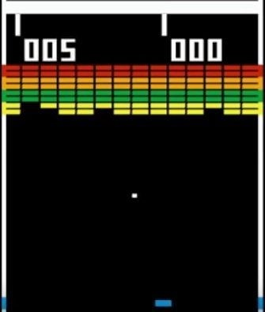

**Figure 2: Steve Jobs and Wozniak working for Atari Breakout Game.**

Video game and arcade consoles are embedded systems, comprising of many components all serving a specific function, allowing the system to take input from the player and relay the outputs on a screen display. Present-day video game console systems generally consist of several embedded components.

Nowadays, there are many integrated embedded systems development tools (software/hardware) are available in the market but your choice is dependent on the type of microcontroller and processor you are using for your development.

1. Discuss the tools that are available based on the above stories. **(2)**
2. Design and develop an Arduino-based games project with the following steps:
   1. Describe the game and the uniqueness of the proposed system. **(3)**
   2. Design the system architecture or block diagram of the operation. **(3)**
   3. Built a programming flowchart. **(3)**
   4. Construct the circuit design which includes interfaces with the sensors, **(3)** actuators and LCD .
   5. Write the programming codes with details comments. **(8)**
   6. Record the demo video and upload to GitHub (Folder name “ESD/FinalExam”). **(4)**
   7. Analyse the system limitations and recommendations for future development. **(4)**

**END OF PAPER**

**Q1)**

**A)** Building Automation

**What is Build Automation?**

A software build is a process that takes source code and other artifacts created by developers and turn them into a software product that can be executed and used by customers. The build may include any of the following steps:

* Compiling source code (in compiler-based languages like C++ or Java)
* Compressing target files into archives (such as JAR, ZIP, or WAR)
* Generating software installers
* Running automated tests on the build
* Automatically deploying software on a target environment

Build automation systems can be triggered in several ways:

* Manual build trigger—a developer requests a new build.
* Schedule build trigger—an automatic build from the codebase every hour, day, week, etc.
* Source code build trigger—many teams automatically run a build after every code commit, in line with continuous integration best practices.
* Post-process build trigger—a build can be run each time a specific process completes, for example after a security scan finishes running, although this is not commonly used in CI/CD pipelines, and all build-related processes are typically run as part of the build script.

**Types of builds are:**

Generally, there are two types of builds.

* Full build—builds the entire software application from the source files. It takes in the full project, checks dependencies, compiles all source code, and builds the target software components, creating the complete build artifact.
* Incremental build—an incremental build takes an existing build, checks what has changed in the source code and artifacts since the last time the software was built and compiles or rebuilds any file or artifact that has changed, or which depends on a resource that has changed. Other files will remain unchanged and be reused from the previous build.

Incremental builds are faster and more resource-efficient but are also less reliable.

**Benefits of build automation:**

Build automation is a prerequisite to the effective use of [continuous integration](https://www.agilealliance.org/glossary/continuous-integration/). However, it brings benefits of its own:

* Eliminating a source of variation, and thus of defects; a manual build process containing a large number of necessary steps offers as many opportunities to make mistakes.
* Requiring thorough documentation of assumptions about the target environment, and dependencies on third-party products.

**Challenges for Build Automation:**

* Longer builds: Longer builds take more time to run, it will increase the developer’s wait time and thereby reduces productivity.
* Large volumes of builds: If a large volume of builds is running, then you will get limited access to the build servers for that specific period.
* Complex builds: Complex builds may require extensive manual efforts and may reduce flexibility.

**Example of the top build automation tools:**



B) **Smart Farming**

**What is Smart Farming:**

The agriculture sector fulfils demand of food of the nation. The agriculture which uses [Sensors](https://www.rfwireless-world.com/Terminology/Advantages-and-uses-of-Agriculture-Sensors.html) and latest technologies such as IoT/cellular is known as smart agriculture or smart farming. Sensors help in mapping fields to understand their micro-scale in order to conserve resources such as water, fertilizer etc. After mapping of crop yields, farmers could monitor and apply fertilizer and weed treatments only to required areas. Moreover, Smart agriculture came to existence when GPS became available for civilian use. Also, Smart agriculture use IoT and cellular wireless technologies for remote connectivity.

**Pushing factors and the issues:**

Big data concepts such as Smart Farming and Precision Agriculture are important. Digital technologies can make food production more efficient by collecting and analyzing data. Besides the increased demand for food, climate change, and the increased food-price-index have influenced the global agricultural yields, as, for example, the global food crisis of 2007/2008 has shown. These are the most important advantages of Smart Farming:

1. It allows farmers to maximize yields using minimum resources such as water, fertilizers, seeds etc.
2. Solar powered and mobile operated pumps save cost of electricity.
3. Smart agriculture uses drones and robots which helps in many ways. These improves data collection process and helps in wireless monitoring and control.
4. It is cost effective method.
5. It delivers high quality crop production.

But as usual there is nothing without drawback, there are two main problems faces Smart Farming.

1. The smart agriculture needs availability of internet continuously. Rural part of most of the developing countries do not fulfil this requirement. Moreover, internet connection is slower.
2. The smart farming-based equipment’s require farmers to understand and learn the use of technology. This is major challenge in adopting smart agriculture farming at large scale across the countries.

Inconclusion, we can notice that the benefits of Smart farming is more than the drawback and by time people will be able to overcome all challenges in the Smart Farming.

**Example:**

Driverless Tractor

The tractor is the heart of a farm, used for many different tasks depending on the type of farm and the configuration of its ancillary equipment. As autonomous driving technologies advance, tractors are expected to become some of the earliest machines to be converted.

In the early stages, human effort will still be required to set up field and boundary maps, program the best field paths using path planning software, and decide other operating conditions. Humans will also still be required for regular repair and maintenance. Nevertheless, autonomous tractors will become more capable and self-sufficient over time, especially with the inclusion of additional cameras and machine vision systems, GPS for navigation, IoT connectivity to enable remote monitoring and operation and radar and LiDAR for object detection and avoidance. All of these technological advancements will significantly diminish the need for humans to actively control these machines.



Fig 1 (Driverless Tractors)

Q2)

1. Atari 2600 Teardown 1977

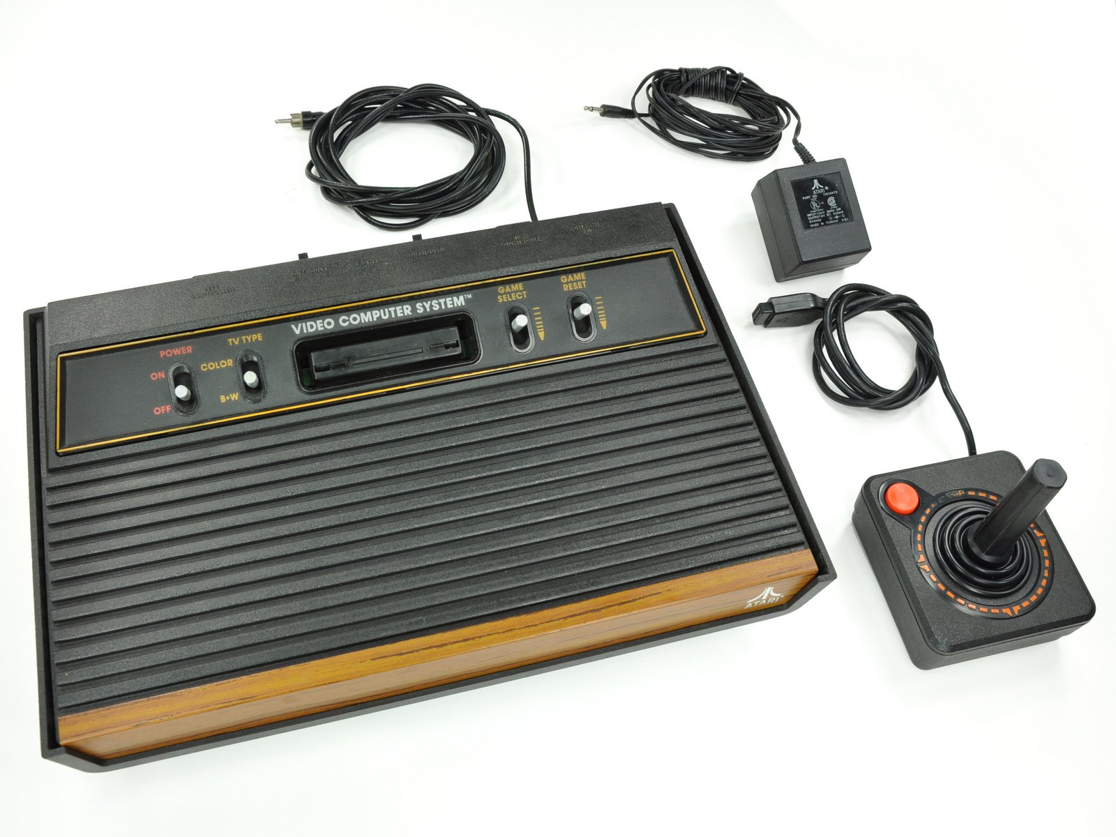

Atari 2600, with AC adapter and iconic joystick controller. And it has another name which is Semiconductor's Video Entertainment System. The console was later renamed after its model number, CX2600.

Motherboard, The Atari 2600 boasts: (1.19MHz 8-bit processor, 128 bytes RAM, 192 x 160-pixel resolution, 128 colors, with max 4 colors per line, 2 channel mono sound)

6532 Ram-I/O-Timer (RIOT) chip and MOS Technology's 6507 CPU

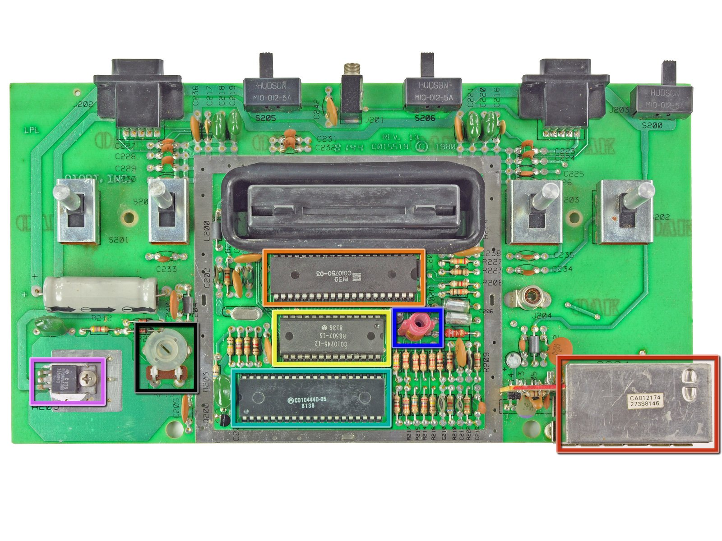

Television Interface Adapter (TIA).

Colour tint adjustment

Sound tuner

RF modulator

Cyan Engineering TIA custom chip (manufactured by Motorola)

MOS Technology 6532 RIOT (manufactured by Synectic)

MOS Technology 6507 CPU (manufactured by Rockwell)

Voltage regulator (manufactured by Texas Instruments)

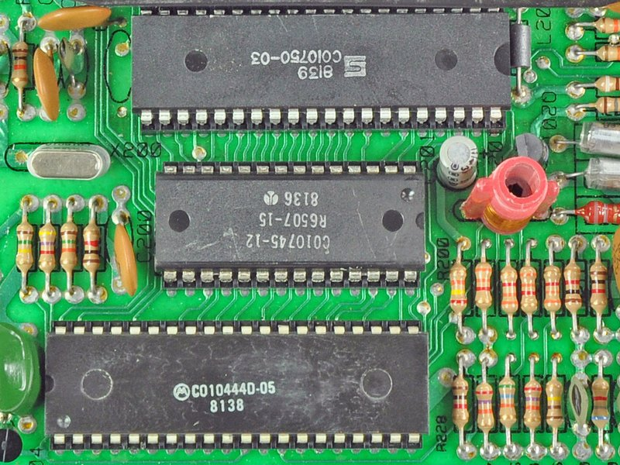

At that time Atari development have to customize their own component like what they did in Television Interface Adapter chip. As it allowed for multiple colors, increased graphic capabilities, and sound. Because memory was so expensive during the 2600's design, the video processor has no external RAM. As a result, the CPU must send video data to the TIA one line of video at a time. More on TIA There are six components of video that the TIA can create: The playing field, Two sprites (8-pixel lines), a "ball" (single pixel), and two "missiles" (two-pixel lines). Combinations of these elements allowed for the complex video games witnessed in the 2600.

B)

I) Describe the game and the uniqueness of the proposed system.

The game rules are very simple basically it is one player game the game called run and jump it will begin with a display shows Jump or Die after that you will have to select one out of four categorize from easy to impossible, than the game will start with a random obstacles sometimes from up some times down, if obstacle is down you have to push a button to jump or you are going to lose, If you failed to pass the obstacle you will lose and a screen will show Game Over. If you want to try again you can simply click the jump button again.

The uniqueness of the game is the jump is controlled by an ultrasonic sensor not with a simple push button this will make the game more interesting also after losing the game the servo motor will point on the red light and if you win will point on the green light. The game can be improving, and we will mention it later in the following questions.

The process of the game is:

1. Game start.
2. LCD show Jump or Die.
3. Select Mode.
4. Push the start button.
5. Control the jump by two ways the push button or the ultra-sonic sensor.
6. If you died from the obstacle LCD ON show Game Over.
7. You can play again by pressing the start button again.
8. After losing the servo motor will turn 90 degree to points on the red LED and LED will be on.

2) Design the system architecture or block diagram of the operation.

Display Unit 16 x 2 LCD

I/O AND O/I

Ultra-Sonic Sensor

O/P

Servo Motor

O/P

Buzzer

I/O

O/P

Push buttons

LED`s

O/P

Control Unit

Arduino Uno

The block diagram works as follow we have a control unit which is in our case Arduino uno which have 2 input and 5 output, the push button is the main input component which will generate the game and control it in terms of selection also jumping and reset the ultrasonic diagram is input and output which will take the data and check if the condition is correct or not if correct the output will be controlling of the jump than we have the LCD Display which will show all the previews input consequences than we have LED`s red and green it will be HIGH only if the player win or lose and at the end of the game, Moreover the buzzer we be on when the game is launching and when the player jump or loses, lastly servo motor will point on the led depends on the condition.

3) Built a programming flowchart.

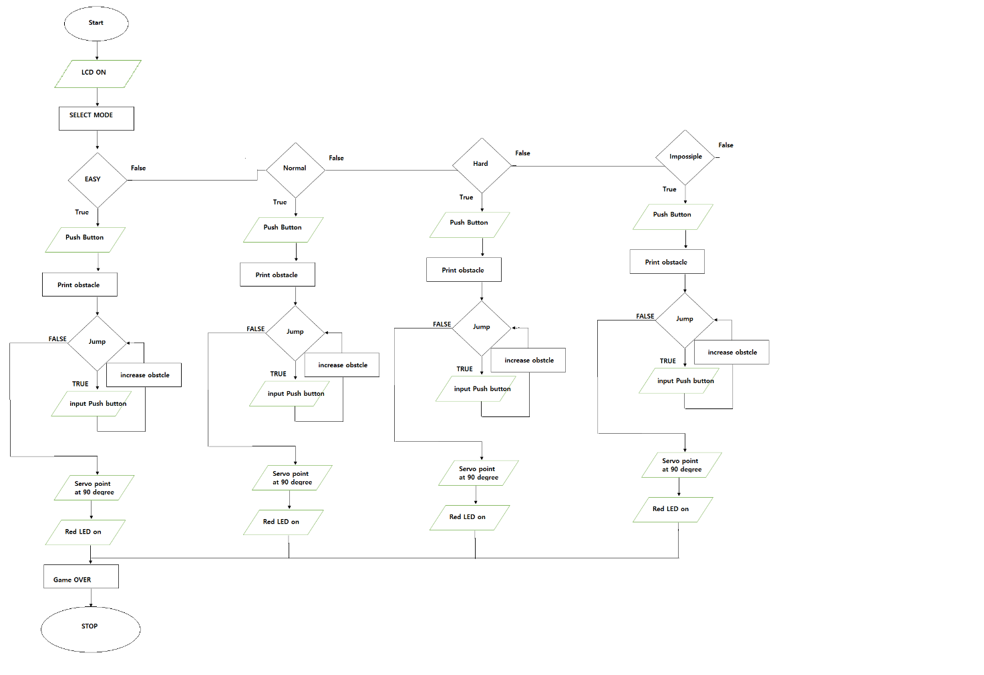

**Notes: I FORGOT TO METNTION THE RESET BUTTON IN THE DIAGRAM.**

4) Construct the circuit design which includes interfaces with the sensors, actuators, and LCD.

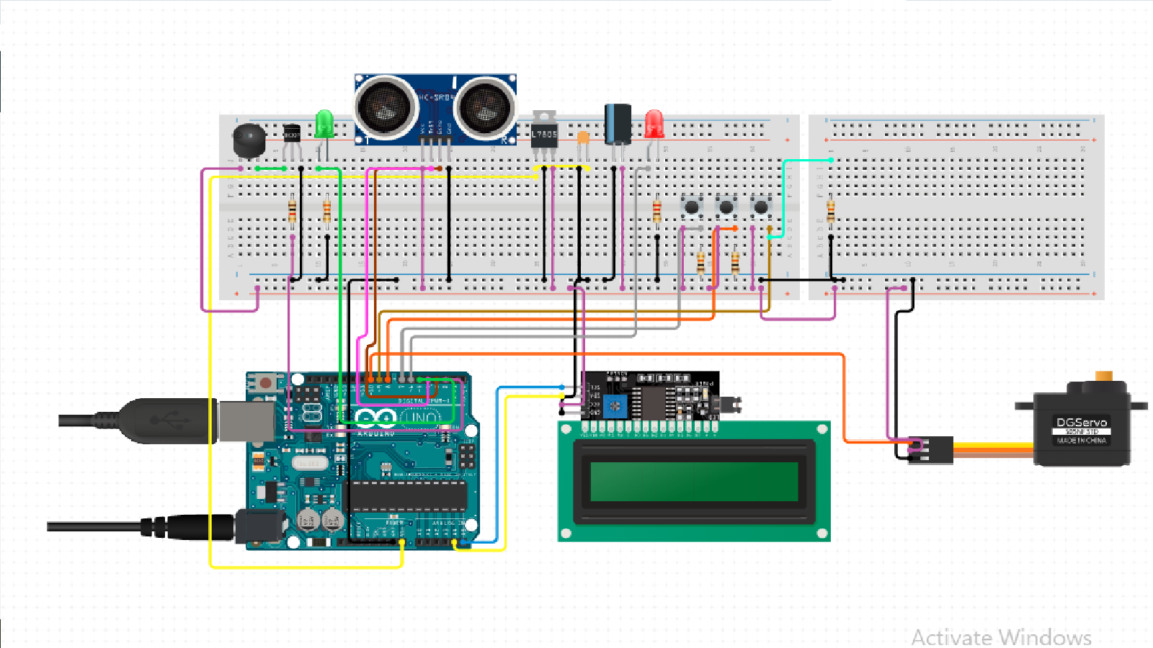

5) Write the programming codes with details comments

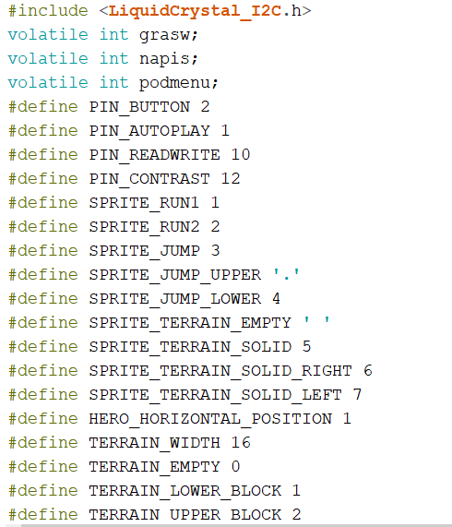

Define LCD library and define the game variable

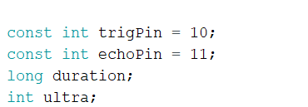

Define ultra-sonic sensor

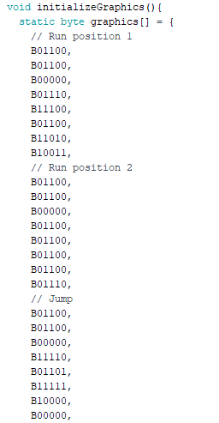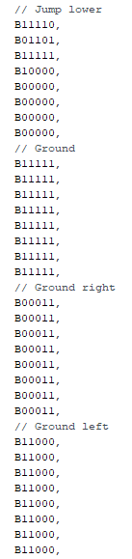

Those command for the graphics that’s why we use one function so it can be easy to call it when we want it

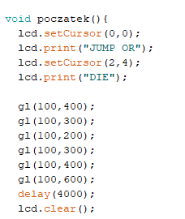this loop for starting and the number 0,0 mean initial point in the screen.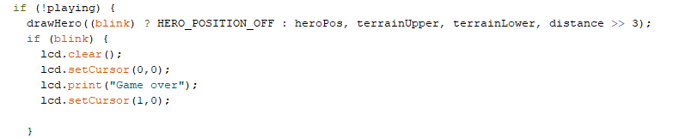this condition when we lose the screen will print Game Over and screen start to blink

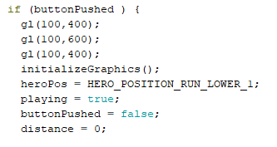this to run graphic 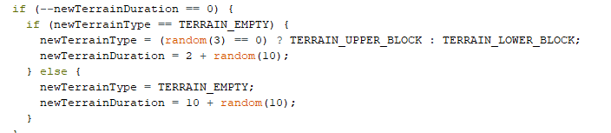this to create new obstacles

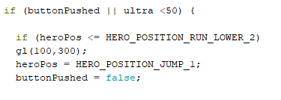this condition to either use the push button or the ultrasonic sensor to jump

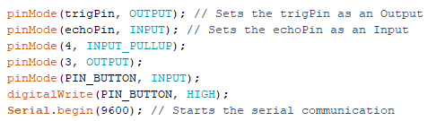code to deine the output and input

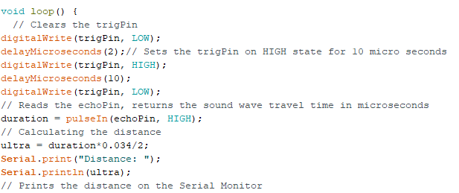print the ultra-sonic sensor value after converting it into a suitable numbers

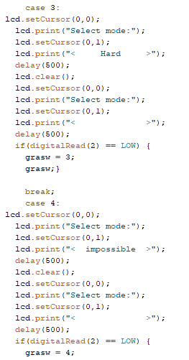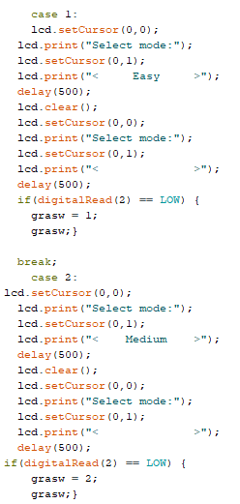

This switch to choose the mode

6) Record the demo video and upload to GitHub (Folder name “ESD/FinalExam”).

7) Analyse the system limitations and recommendations for future development.

As an embedded system engineers while developing the proposed game we go into some limitation which are:

* The game is not smooth
* The game speed will not change overtime which will make the game boring.
* The controlling is not that accurate especially for ultra-sonic sensor.
* No finial score for winning.
* No price or gift for the winner.

Recommendation and future work:

* Connect the game to IOT so the scores will be saved on the cloud and will be share to other player which will create a better gaming environment with a competitive experience.
* More Developing on the code.
* Focus more on the Outer design and wiring.
* Make the game portable.
* Make a game story which will make the game nicer and more interesting.

Some of the limitation is here due to lake of experience with the gaming environment and the components.

While developing a game the process needs sometimes to do the testing and have the full vision what does the code done and how to be creative.

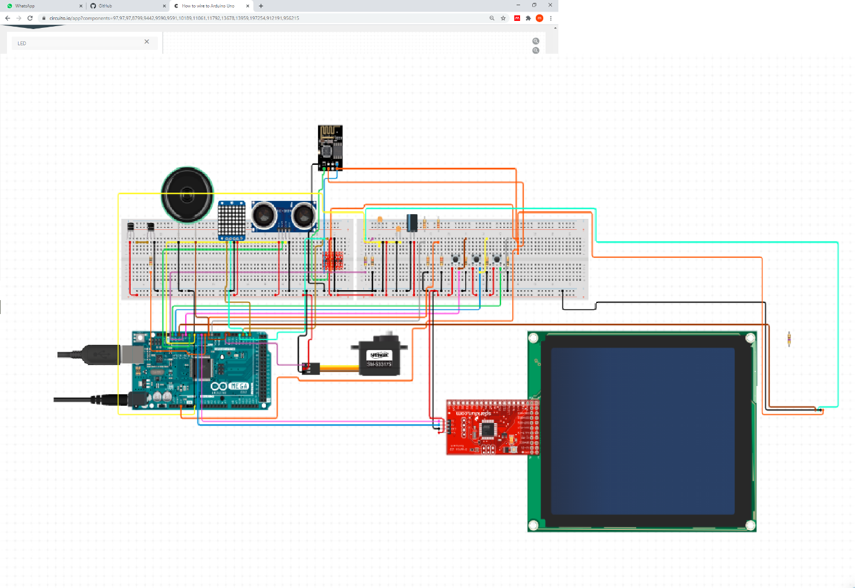

The preview circuit diagram illustrate some of the future work that hopefully can be done the circuit show some feature like the big screen and the LED 8X8 MATRIX WHICH WILL HELP IN THE LOSING OR WINNIG TIME which can show the LETTER W for win and LETTER L for lose the 160x 128 LCD will give a better gaming environment also now we can use the project not only for one game for multiple games the speaker also were added to ensure the sound can be good.

The Final project with components:

|  |  |  |
| --- | --- | --- |
| Component | Quantity | Price RM |
| Arduino UNO | 1 | 25 |
| Board | 1 | 4.9 |
| Push Button | 3 | 0.9 |
| Ultrasonic sensor | 1 | 3.5 |
| Buzzer | 1 | 2.5 |
| LED | 2 | 1 |
| Servo Motor | 1 | 10 |
| LCD 12C 16X2 | 1 | 13 |
| Wier Male to Female | 22 | 5 |
| Resistor | 1 | 1 |
| Total | 34 | 66.8 |

